**Department of Computer Science, Aberystwyth University**

12

**Industrial Year Report**

**Aberystwyth University Information Services**

**Jack Jenkins**

Table of Contents

Introduction 1

Organisational Environment 1

Background 1

Information Services 1

Business Information Systems (BIS) 1

Library Services 1

ICT & Customer Services (my division) 2

Technical Environment 5

Systems Used 5

Sunrise 5

Reg 5

Interzone 5

AsTRA 6

PCounter 6

Sharepoint 7

SNMPc network manager 7

Hardware 8

Office Hardware 8

Public Computer Rooms 8

Public Printers (MFDs) 8

Filestore 9

What I did 9

Introduction 9

Core Duties 9

Phone 9

Mail 10

Enquiry desk 10

Tasks duty 11

Printers support and breaks 11

Other duties 11

Projects and Personal Tasks 12

Foursquare – first trial project 12

Exchange conversion 12

Horde 12

ShowMe videos 13

Public printer training 13

Clinics 13

FAQs 13

Critical Evaluation 13

Bibliography 16

# Introduction

During my industrial year I was employed by Information Services (IS), a service department that provide Library, IT, Information Management and Media Services to Aberystwyth University. The services offered are wide-ranging, therefore IS is divided into three main groups.

I worked on a 13 month placement, extended to 14 months, for the Customer Services team within the Information Services department from July 1st 2011 until August 31st 2012. Five industrial placement positions were advertised and interview for, three positions within Customer Services two within Media and Technical Services. Following this, people were offered positions based on the outcome of the interview.

# Organisational Environment

## Background

Aberystwyth University is an academic institution located in Aberystwyth, Wales. The University was established in 1872 as University College Wales in a half-finished hotel on Aberystwyth’s seafront. Since then, the number of enrolled Students has grown to nearly 15,000[1], the University has expanded into new buildings on multiple campus’ and enrols distance learners. The University receives it’s income from a number of sources such as student fees, research projects and public funding from the Welsh Government[2].

Professor April McMahon is the Vice Chancellor or the Head of the University. The University has 17 academic departments spread over 3 faculties. The University also has a large number of service departments that run the University, or offer services to those inside and outside the institution. These service departments include those for maintaining the campus (Estates Office), recruiting students (Schools & Colleges Liaison) and managing finances (Finance Office). Each University department may be split into divisions, have their own hierarchy of Staff and are normally led by a Head of Department (it is possible that some departments have multiple leaders).

## Information Services

### Business Information Systems (BIS)

BIS were responsible for developing and maintaining information management systems for the University. The applications that they develop run on Oracle Solaris and Microsoft Windows Application servers which usually reference an Oracle database server. One application that they developed in-house is AsTRA (described later), which is used by IS Customer Services and other departments within the University.

### Library Services

#### Collections & Resource Management

The Collections & Resource Management division were responsible for collection, management and acquisition of materials (e.g. books) and electronic resources. The E-Services and Communications division were responsible for maintaining services such as Blackboard, a learning management system used by Staff and Students. The IS News is one form of communication that they manage, this news is displayed on the IS home page (<http://aber.ac.uk/en/is/>). The Academic Services division were responsible for liaising with departments regarding their information and literature requirements – supporting Staff, Students and to Researchers.

### ICT & Customer Services (my division)

#### Development

This team were responsible for developing and maintaining University systems such as the Staff email system, which was recently upgraded to Microsoft Exchange Server 2010. They also developed tools for the department such as Reg, which is a front end to manage the database of users computing accounts (which they also maintain). The Development team act as 3rd line support, they were therefore left to develop and maintain systems “behind the scenes” and would rarely need to have contact with a customer.

#### Network & Telephony

This team were responsible for developing and maintaining the University’s network. This included the LAN, mainly used by Staff on campus and Students in halls of residence, WLAN which is used by Staff and Students on campus and in halls of residence and maintaining outside network links to affiliated institutions.

#### Systems Support

Amongst other things, this team were responsible for monitoring IS Servers and maintaining the Public Workstations (PSV). Maintaining the workstations included rolling out new PSV builds (a standard set of programs and configurations), Windows updates, security patches, software updates and managing licenses. The Systems team acted as 2nd line support, this means that they were the direct support for the IT enquiries team if advice or a second opinion was needed. The Systems team would rarely need to speak with a Customer directly, although would have more common contact than the Development team.

#### Media and Technical Services (Workshop)

The Workshop completed jobs created or assigned to them through Sunrise, the job description / support ticketing system. The IT enquiries team of Customer Services would assign a job to this team when a 1st line fix was not possible. Any hardware faults with PSV machines were assigned to the Workshop (the Systems team dealt with all other PSV issues). All teaching rooms in the University were supported by the Workshop, every centrally timetabled had a telephone that would dial straight through to the team or to Customer Services. Media and Technical Services charged an hourly rate to customers (Staff, Student, external) for their services.

#### Trading

I have always known this team to be called Sales or Procurement. This team were responsible for purchasing equipment for the department at the lowest costs by leveraging deals with suppliers. The team also sold old redundant equipment externally. The Sales team sell items such as desktop computers and laptops to customers that are referred to them by Customer Services. This team were also responsible for billing customers on behalf of the Workshop.

#### Customer Services (my sub-division)

The Customer Services team were the 1st line of support to customers (Staff and Students of the University); this meant that Customer Services were the first point of call with any enquiries, acting as the face of IS. The Customer Services team dealt with a wide range of general library and IT enquiries. Anything that Customer Services could not deal with themselves was passed onto one of the other teams described and show in the chart. Although basic IT and library queries and procedures were dealt with by everyone, there was a clear definition between IT and library staff, seated in separate sections of the office.

##### Library enquiries / Lending team

This team’s main responsibility was to deal with library enquires and they were responsible for other lending services. The library enquiries team answered emails that were passed to them by their team leader. Within Customer Services, the librarians were most familiar with library procedures and therefore dealt with more complicated requests such as inter library loans (Document Supply). Any library invoices, complaints or other more major issues related to library accounts were passed onto the Lending team leader. The library lending team also produced the majority of ID cards, even though parts of this were shared with the IT team.

##### IT enquiries team (my team)

This team were responsible for all IT enquiries, general (non-technical) enquiries and some library enquiries. The IT enquiries staff were the team that monitored the IS mailbox, answered the publically advertised phone number for IS and operated the IT side of the library enquiry desk. This team were responsible for assigning jobs to other teams within the organisation, when it wasn’t the responsibility of Customer Services to deal with a particular enquiry.

##### Media and Sales

Media and Sales were responsible for the sale of a number of consumables such as DVDs, USB pens and ink cartridges. They were also responsible for administering IS loan stock, as members of the University could borrow equipment such as laptops and video cameras for free, for a short period of time. The team also ran a number of staffed services such as professional printing and binding. Media and Sales were not responsible for handling any IT or library enquiries.

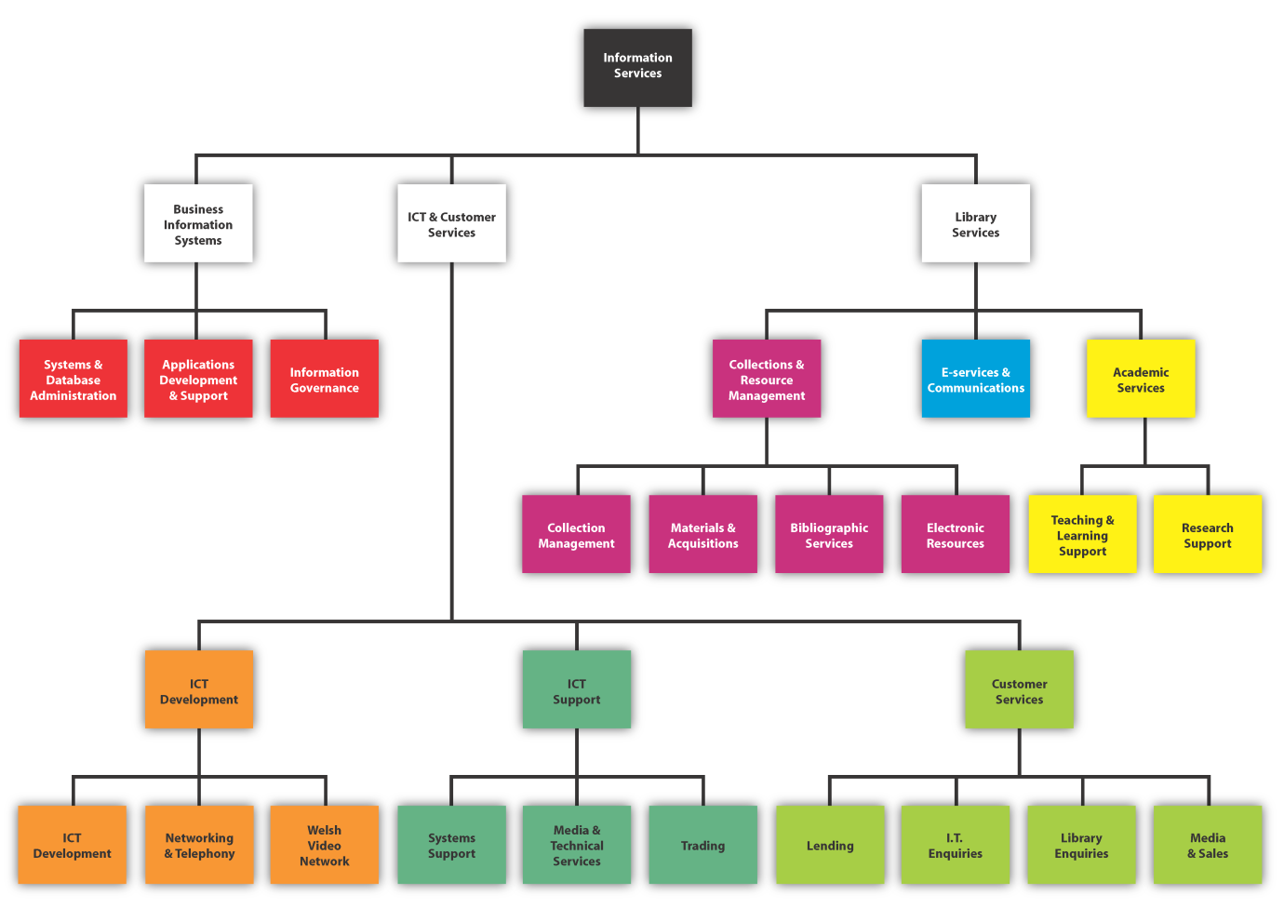 (Information Services, 2011)

# Technical Environment

## Systems Used

### Sunrise

Sunrise is a support ticketing and job allocation system used by IS. The system is used to open and describe a new “job” to be completed, jobs are categorised and can be allocated to either a team or an individual. Once a job has been opened, its status can be tracked by the unique reference number, or by other criteria such as email address. The user who made the request is sent the initial job description, progress updates during the process (if applicable), and a notification when a job has been satisfied.

Sunrise was mainly used by my team and I to create and assign a “job” to another team when a 1st line fix was not possible. It was also used by the IT enquiries team for fault reporting, so that internal issues could be investigated, or so that faults could be rectified before a User has reported it (such a PSV not functioning correctly).

### Reg

Reg is a web interface for managing AU computing accounts. Computing accounts of different types (e.g. Staff, Undergraduate and Postgraduate) are used by members of the University to login to public workstations, for authentication when connecting a device to the network, accessing e-resources, and is the account used for email access.

I used Reg on a daily basis for actions such as changing passwords, locking / unlocking accounts, activating accounts and retrieving user details. I also used Reg to create temporary accounts, re-name accounts, expire accounts (set them to lock, so that they cannot be accessed) and extend the expiry dates on accounts.

### Interzone

Interzone is web user interface used by IS to register network devices and to manage devices registered to Users on the network. The University’s LAN and WLAN features 802.1x authentication, therefore any devices that need to be registered before they can connect to the network.

I used Interzone to register devices to users; The process involved entering the MAC address of the network interface of the machine, which department they were working in and what their location was. After entering these details into Interzone I was able to assign a device to a specific VLAN from the suggested options. A Virtual LAN is when a physical network is partitioned into virtual networks for easier network management. Interzone validated and checked my input against the server(s), then an IP address was assigned to the device and a machine name was auto generated for the device, based on a naming scheme of department and device type followed by the registration number. For example an Information Services library PC may be named libpc0005 – this machine can be recognised as a library PC, and is the 5th registration in the series.

Interzone was a useful tool for troubleshooting network issues, for example I could check (by device) whether a User’s credentials were authenticating successfully against the radius server – logs would show what username was being received by the server (if any) and whether login was successful. If a login was unsuccessful it meant that the username or password was incorrect or the account was locked. Without this information, troubleshooting would have taken a lot longer. I could also check the step after authentication, which is the request and allocation of a network lease from the DHCP server, so that the device can communicate on the network.

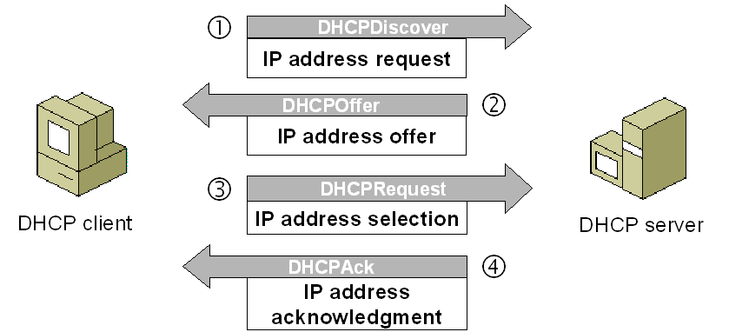 (Microsoft TechNet, 2005)

### AsTRA

AStRA (Aberystwyth Student Records and Admissions) was developed in house by BIS using Oracle Forms and Reports . The database for AStRA holds Student records, Staff records, Module information, ID card information and other data. AsTRA is accessed by clients via a Java web application over a VPN connection. AsTRA sends updates to the Reg system on a daily basis to ensure that computing account details are current.

I used AsTRA to access Student records for the purposes of checking answers to security questions, I also checked whether academic module information was valid when there was a lock code on a User’s account associated with this. This enabled me to inform the User of what the issue was (such as student registration incomplete), or pass the issue onto another department.

I also accessed AsTRA for the purposes of ID card production and for investigating ID card related issues, for example to find out why the card wasn’t working on the door locks – after I had done a number of checks I could pass on an issue to the Systems team if it was un-resolved.

### PCounter

PCounter was an application that was run on a server to allow some basic administration of user print profiles, associated with their account. PCounter is used to check and update print balances, view printer reports and it can also be used to retrieve an emergency code so that someone can print without their I.D. card, which is normally used to release a job on a printer.

PControl was a sub application, also ran on from a remote location – this application allowed me to monitor and delete jobs that were queued up on the print server and indicated what printer the job was being released to (if applicable). PControl was useful for checking the status’ of printers as I could see if there was problem somewhere – these problems needed to be picked up quickly to stop a back log of jobs building.

### Sharepoint

Microsoft SharePoint (Server 2007) is enterprise collaboration software, it ran on it’s own server and was accessed by clients (Customer Services / our Customers) via a web application. Tasks were created by by manager and assigned to me on Sharepoint, whenever I made any progress I could update the description of the task and update the task completion percentage. This allowed both my Manager and I to keep track of progress. I also used Sharepoint to view procedures, review and update stats and also to view many other kinds of shared documents. Although I had no personal permission setting ability, I did offer assistance to other users with setting permissions on their own departmental sites, or set them on their behalf by using remote assistance.

## SNMPc network manager

This is network management software used to manage devices on the network. I used it to monitor the status of different parts of the network, it was a useful tool to have if you suspected there was a network problem somewhere. If an icon flashed up red in this software, in meant there as a problem – these problems would reported to the networking team immediately (they monitored the network themselves too).

In the following diagram it is possible to see the map of the University’s network – the top of a number of network trees are displayed, these trees are for different areas, buildings or halls of residence. Purple and green indicate OK, yellow indicates a possible issue and red indicates an issues, such as an unreachable device.

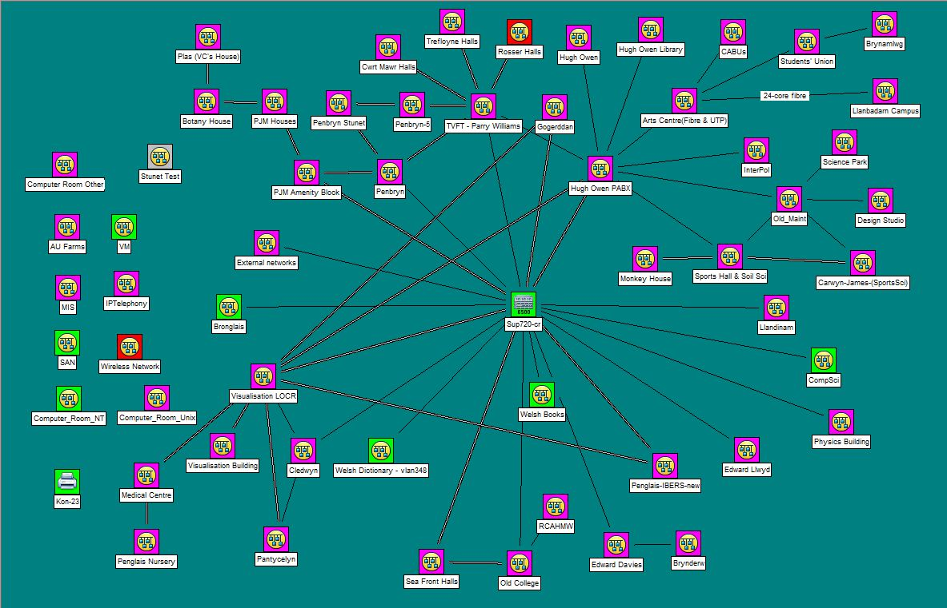

(Information Services, 2012)

## Hardware

### Office Hardware

My machine ran had a moderately powerful dual-core processor, a small size hard drive, 4GB RAM and a graphics card powerful enough to support two monitors. Customer Services machines had two monitors to enable more efficient multi-tasking, so that we could deal with queries while accessing resources such as procedures at the same time.

Other equipment in the office included a number of machines for testing procedures and services such as an Apple Mac running OSX Lion, a Toshiba running Windows 7, a desktop multi-booting Windows XP, Vista and later Windows 8 and a number of peripherals such as an external DVD drive which could be used on the enquiry desk.

### Public Computer Rooms

IS provide approximately 600 networked workstations in 23 areas, for public use on campus. Machine specifications vary; however a typical machine has low spec dual core processor, 2GB RAM and a small hard drive. All machines have a TFT monitor and run Windows 7 Enterprise. All machines are connected to a Windows domain named PSV, the domain is controlled and managed using Active Directory Services on a server running Windows Server 2008 R2.

A common set of software is available on public workstations; this includes Microsoft Office, Adobe Acrobat and Putty, amongst many others. Software installed on the PSV machines is distributed by Windows Server 2008, supported by other systems management servers[3].

The Systems Support team were responsible for supporting the back end technical issues with these services, however it was Customer Services who assisted end users with using software on these machines, accessing their network drives, saving files in the correct locations and accessing scanned documents from the IS server on these machines.

Some computer areas featured additional equipment such as a Public MFD (multifunction device), flatbed scanner, Microfiche (photographic film) reader and equipment to provide additional accessibility.

### Public Printers (MFDs)

Public Printers supported by IS are connected to the LAN, they process jobs that are released to them from the print server. Print jobs are sent to the public print server by users on the AU network, a user can release a job (send to printer) by swiping their Aber Card on the terminal connected to a public printer.

MFDs are capable of printing, copying and if a computer terminal is attached, scanning to a personal network location.

The Public Printers are Konica Minolta Bizhubs, leased with a maintenance contract from Konica.

### Filestore

Every user of the University is allocated a filestore of 2GB in size. This filestore was centrally managed on IS servers, therefore was the responsibility of the Systems Support team to backup and maintain these servers on a daily basis.

# What I did

## Introduction

When I joined Information Services I attended a number of training sessions, these covered things like the rules and regulations of the workplace, how to deal with Customers in different situations and an introduction to unfamiliar services such as Primo, the University’s library database. The majority of my training involved shadowing existing members of the team and learning as I went along – being supervised as I answered emails, calls and served on the help desk. The aim was to be mostly independent within a month, as this is when new Industrial Year’s replaced existing Industrial Year’s – a daunting prospect at the time.

I found myself positioned in a team which varied in size throughout the year from between 3 permanent Staff to 6 members of permanent Staff, plus 2 other Industrial Years . The numbers varied as some Staff were positioned temporarily in other teams, one was on long term leave and one initially only worked half a week with IT and half a week with the library team.

Information Services aim for Staff and Students to contact IS through a single point of contact, some of my duties and the typical enquiries are described below.

## Core Duties

### Phone

One of my regular duties was answering phone calls, initially this was very daunting and my most dreaded shift, but as confidence grew, this grew to be an enjoyable shift. Customer Services had a shared VOIP profile (phone number), used by the IT enquiries team only. Therefore when I was on phone duty, I would log in to my personal VOIP phone using the Office’s credentials so that I could pick up phone calls from people calling the publically advertised IS Customer Services number. This involved serving customers over the phone who had a wide range of IT skills.

Common queries received would be account related and network related issues, along with fault reporting of printers, computers and other devices.

I made extensive use of remote assistance while on phone duty, via Remote Desktop Connection to machines based on the University campus or via a third party solution ShowMyPC to users who were off campus, the use of remote assistance is bound to have saved IS a lot of time. This was a useful tool when assisting customers who were not very computer literate, as these services allowed me to take full control of a user’s computer while being able to view what was on their screen. When appropriate for use, remote assistance allowed a problem to be defined then investigated more quickly, rather than blindly getting to the bottom of the issue through questioning then explaining the solution, which would have been a slower process in the vast majority of cases. My aim was to get customers back to work as quickly as possible, always explaining the fix in layman’s terms, as I appreciate that IT issues can be seen as a frustrating barrier, therefore education may be able to help them next time.

Phone duty was initially the scariest shift as with a phone call you are put on the spot and must answer the query immediately (if possible), whereas answering emails allows you to have more time to form an answer. However after the first couple of months, I relaxed into the role after knowing the common queries and the best way to deal with difficult ones (e.g. ask for as much information as possible, then put them on hold to seek advice).

### Mail

One of my regular duties involved answering emails; this was probably my favourite shift. We accessed emails through a shared Office Account, which was on Microsoft Exchange 2010, a client-server collaborative application for syncing mail, tasks and calendars. The single mailbox would be monitored by everyone in the IT enquiries team. Therefore I was responsible for answering these queries and resolving as many issues as possible as a first line fix (the aim of Customer Services). I worked through email in the order that they were received; occasionally checking through newer ones incase any queries should take priority, such as reports of important system issues or failures.

A common query would be troubleshooting a networking issue, which could begin from a user “xxx99” with the message “I cannot connect to the internet on my laptop” along with varying amounts of other details, it was important for me to narrow down the possible issue in the least steps / amount of time possible. The general response to this query would be to point them to network troubleshooting FAQ’s, which include manual checks and automatic setups. Other things I would investigate based on the information received would be to look at the machines registered to “xxx99” on Interzone, I could search the database and then look at their logs to see if they had authenticated with their correct credentials against the radius server. I could also check the account belonging to “xxx99” on Reg incase their account is locked for any reason. Information would be sent to the user asking them to try things or asking for more details where appropriate (such as are they using an Ethernet connection). Where it was at all possible, I would advise anyone with a complicated issue to bring their device to the enquiry desk or to call us up for remote assistance if it was convenient, as this was much less time consuming for both parties.

### Enquiry desk

This shift meant working on the enquiry desk on the bottom floor of the Hugh Owen library I would predominantly take on IT enquiries, however working on the IT side of the enquiry desk also meant taking library enquiries and general queries. The desk was open 9am until 5.30pm during the day, a shift would last half of the day. Thomas Parry library on another campus also had a helpdesk for IT enquiries, however during my time with IS, this was only temporarily used during a small portion of the year, due to how unused it was. Queries at the desk had a target of completion of under 15 minutes, where appropriate we would help for longer as long as it made sense to continue.

I answered queries face to face at the enquiry desk, if I couldn’t solve a problem then I would walk back into the office for a second opinion from a colleague – this happened a lot during the first 3-6 months, however much less so afterwards. If a query could not be dealt with at the desk, then I logged a job on Sunrise so that 2nd or 1st line support could offer advice, take an action (e.g. filestore file recovery) or come and see an abnormal problem for themselves (e.g. laptop can’t connect to the network). If there was a hardware fault, virus or larger software challenge like the re-installation of an Operating System, then this would count as a potentially chargeable job that was logged on Sunrise to the Workshop.

The majority of queries were either account related or network related. Account related queries would commonly be a forgotten password or a locked account for a reason unknown to the user. Network related enquiries commonly involved setting up a computer to connect to the LAN in their Halls of Residence or Eduroam, the Univesity’s wireless network. Other common queries were regarding personal website development, club & student society accounts and slow computers.

Queries were easier to resolve at the desk that over the phone or by mail, this is because the customer could bring their device in and I could see the problem for myself, while they talked me through the difficulties that they were experiencing.

### Tasks duty

When I was allocated a tasks shift, this allowed me to concentrate on completing any outstanding tasks assigned to me on Sharepoint, complete FAQs assigned to me and to check FAQs for integrity by going through the FAQ report (see FAQs). I often found myself answering phone calls and emails during this shift when it was busy, as in most cases a waiting customer should take higher priority.

### Printers support and breaks

While allocated on Printer Support, I was responsible for monitoring printers for issues such as jams, replenishing paper, replacing toner and replacing imaging units. Paper was replenished twice a day in the library – once in the morning, once in the afternoon. Apart from this, the maintenance procedure followed a reactive approach; therefore paper would not be replenished in other locations until it ran out, or until I spotted a message to say that the final paper tray was low.

The two most common issues with the printers were firstly paper jams – this require opening the printer with a key and opening various sections to find the jam. The other common issue was print jobs being released to the printers where there was “no matching paper size” (paper size not detected to be A4/A3) – this was particularly annoying as it halted any further jobs until the job had been deleted, during this time a user may have tried releasing a job on other printers putting those out of action too. The resolution to “no matching paper size” was to delete the job, this could only be done physically at the printer, then to educate the user to use standardised print margins and to choose the print size as A4/A3.

If there was a more serious technical issue that could not be resolve by us, we would open a support call with Konica and they would send an engineer out to investigate.

### Other duties

Other duties performed while on another shift included the production and testing of ID cards, for example troubleshooting why a card would not swipe on a public printer. I also helped out with library enquiries by checking Primo for books (e.g. availability / location), charging / discharging items, processing library fine payments and retrieving theses from the store room. During vacation opening hours we assisted porters in clearing the library at closing time, as there are three library floors that need to be emptied before locking up.

## Projects and Personal Tasks

### Foursquare – first trial project

My first project was to investigate the use of Foursquare on campus. I initially investigated and found that our Foursquare presence as a department was incomplete, for example some of our computer rooms were missing or did not follow a conventional format. I also had to contact Foursquare regarding obtaining window stickers in English and whether we could produce them in Welsh. However during my investigations, I had found that another department within the University had taken on this project themselves. The department responsible marketing had already overhauled the main University Fourquare pages, they had done so with the assistance of the Web Team. It was decided that after creating a short list on our own departmental Foursquare account, we should leave the maintenance to the other University departments, we do however suggest changes from time to time.

### Exchange conversion

One major project handled by IS was the migration of all Staff and other non-Student accounts that existed on the old IMAP server to Microsoft Exchange. This took place to unify all of these types of accounts for easier maintenance and for easier collaboration between Staff, with the aim of efficiency savings for all (amongst other reasons).

Before the migrating project commenced, I was involved in this project by answering any queries that users had and providing them with more information where there were worries or the FAQs were not enough. During the migration between servers, I was responsible for assisting users with the process of accessing their mail on the new server, where they were having technical issues or difficulty in following the instructions provided. I assisted in the mapping of a new mail account to a mail handler, predominantly Outlook 2007 / 2010 and following that I assisted with copying over the old emails for the user, when this was requested. Where a user did not use a mail handler, I would open a job for the Systems Support team to move the mail on behalf of the user.

### Horde

I played an important role in the trial of a new student email system called Horde. Everyone in IT The IT enquiries team of Customer Services tested Horde on different systems and in different web browsers for compatibility and review, however I was allocated more time to run tests on various features – such as mail filtering, re-filing and testing attachments.

I was the person responsible for initial processing all feedback received by IS and was the point of contact between the 1st line Customer Services and 3rd line Development team. I collected the useful feedback into a document and passed on any important feedback or suggestions to the Development team (after testing, if applicable). I had a number of discussions with a member of the Development team regarding bugs and proposed changes, one proposed change was that new emails should be shown first rather than “oldest unread email”, after my own experience and feedback received from users.

At the end of the trail period I had to present a feedback document in a meeting to a member of the Development team, Assistant Director of IS and ICT Customer Services manager, this analysis of user feedback also included suggestions of other services available and what institutions currently use them. My contribution was important as this meeting decided whether we were going to proceed with the project or postpone any changes, eventually the project was postponed due to lack of resources.

### ShowMe videos

ShowMe videos were another project undertaken by the Customer Services team. A colleague and I produced a number of demonstration videos within the library, on behalf of Academic Services. The process would begin by writing a script or storyboard so that we know what to film, then we would take it in turns to film and appear in different instructional videos. Later, between us we would record sound for the videos in English and Welsh. Finally we would use PowerDirector for editing and combining the muted video with our voice overs, before finally uploading the videos to YouTube. The videos will be shown to new Students during induction talks, they are available on the IS Youtube site and will be embedded into a number of FAQs. My colleague and I were both bilingual to a basic conversational standard, I believe that this is the reason why were chosen.

### Public printer training

I ran a public printer training session for IS staff. The Customer Services team support a number of public printers, however other members in IS are encouraged to help with some of the basics and to report faults to us as soon as possible. I explained the procedure on filling the printers and how we otherwise maintain the printers (such as replacing toners), I also proceeded to show them the locations of these supplies.

### Clinics

I ran a number of one to one clinics. One clinic was helping a Staff member with the use of PowerPoint before a presentation. The member of Staff wanted to know how to apply automatic timing, transitions, a common theme and they also had some other questions which I answered at the time. Another clinic that I ran was to help a PHD Student with the formatting of their thesis. They had already written their thesis and had spent time formatting it, however they needed help with some more advanced features like single page orientation and including multiple numbering schemes within the same document. Therefore I showed them how to do these things and reminded them that they must use standard headings and styles for the best result when formatting.

### FAQs

I was assigned with the task of writing a number of FAQs from scratch, I was also assigned a number of FAQs that required a big overhaul or needed updating. I also ran the FAQ reporter which runs a query on our FAQs and generates a report showing the FAQs that need to be reviewed, then marked as completed after checking for accuracy. If any small FAQs required translation, I give it a go myself and then passed it on to a member of my team who could also speak Welsh, for checking. The majority of completed FAQs were then sent off for translation, so that IS comply with the University’s bilingual policy of equal treatment of English and Welsh.

# Critical Evaluation

When I joined the team in Customer Services, I was surprised to find out how small the team was – I don’t think that people outside IS realise how small the front line team are and how much we are expected to know. The existing IY’s were a great to have around to answer any questions and to help out with any customer queries. When it was coming up to the current IY’s time to leave, the new IY’s and I thought “what are we going to do now?!”. We needn’t have worried though.

I have firstly gained a greater understanding of how organisations and technical organisations are structured. I learnt about the re-structure of the department over the years, I believe that one core Customer Services division with knowledge of IT and the library side of things is the most effective way to tackle queries. For example I now know that IT enquiries staff may not have a lot of contact with Systems developers that work behind the scenes – I didn’t speak to some members of IS Development once during my 14 months. It wouldn’t make any sense for these other people to be bothered with more minor technical enquiries. I do however criticise a communication barrier between the IT enquires team and other divisions of IS, there is a common mentality that I felt of “keep it downstairs”, which is where we worked, this was a mentality that I know is shared with some people from “upstairs”, which is where the rest of IS worked in this building. These barriers can’t exist if an organisation wants to be 100% efficient, luckily it wasn’t a very big deal and it didn’t affect work much. One example is when I had a customer on the phone asking for support with Panopto, which is lecture video capture software, this is software that I have never used myself – therefore quickly reading up on information, I was able to give the basic expected troubleshooting advice, when I tried to pass it on to a member of the another team they were unwilling to take the call off me, so I had to save them the embarrassment

In Customer Services there is a large amount of library staff , they are all nice people however some of them have no IT skills and library specific knowledge of only equal or very slightly higher than I had, when I’m someone who hadn’t used the University library before. A proportion of the team should be made redundant, then their positions re-filled with staff who can answer library and IT enquiries, like one member of staff which we had within the IT team for the majority of the year.

I had customer services skills before my placement from my previous work experience as a sales assistant in retail – this put me in very good standing as I already knew how to treat customers, act professionally and how to deal with complaints or angry customers. I already had IT skills going into my placement due to my previous education at school and University. I also already had some troubleshooting skills through helping family and friends.

I don’t believe that I gained a great amount of skills and knowledge specific to the subject that I study at University, I do however believe that I have gained a lot of valuable skills which will help me in my future career. One skill that I developed was my ability to tackle a problem, by working for IS I am now better at finding out where a problem lies, then breaking down a solution so that a task can be completed in the minimum amount of stages possible. One example of this is I now know how to troubleshoot networking enquiries by checking Windows services, checking if a network interface’s drivers are up to date, along with other methods which I wouldn’t have known before completing my placement. I also learnt how public workstations and an Organisation’s employees may be supported on a network in an enterprise environment, for example the use of domains of users who share the same set of security principles and I have learned how a Systems team would effectively roll out changes to a large amount of systems. This knowledge would benefit me if I were to work in a similar environment in future.

I greatly enjoyed my Industrial Year at Information Services. The best part about my year was working with a great team of people. We had an excellent manager who was helpful, caring and always easy to approach – her door was always open and she always knew the best method of solving a problem, or would remind us that a procedure for a question already exists on SharePoint! The rest of the team that I worked with daily were also great – any questions or ideas could be passed around with ease, we’d work together to solve any more difficult issues and there was a good balance between office humour and work, as we would always get the work done.

Another highlight of the job for me was the satisfaction of having a happy customer after resolving an issue. I can understand the huge frustration to customers when there is a computer related barrier in their way that they just don’t understand, sometimes it’s their fault and sometimes it isn’t but have still been presented with an issue. Talking to the customer, explaining the reasons why something happened and going through the troubleshooting stage with them was satisfying as it helped explain some foreign words and concepts to them, while building my confidence and knowledge of the subject. At the end when the problem is resolved, if you have taken the time to be friendly and explain the problem to the customer (if they are willing to listen that is) then they are more likely to be able to work problems out for themselves in future, or may return the favour of assistance some day in an area foreign to you (e.g. another service department).

I’m glad that I chose to take a year in industry – I’ve gained experience which I can put on my CV, built confidence in expressing my opinion within teams and earned some money along the way!

# Bibliography

Aberystwyth University. (2011). *Financial Statements for the Year ending 31 July 2011.* Retrieved September 15, 2012, from http://www.aber.ac.uk/en/media/2010-11.pdf

Higher Education Statistics Agency. (2011). *Table 1 - All students by HE institution, level of study, mode of study and domicile 2010/11*. Retrieved September 15, 2012, from http://www.hesa.ac.uk/dox/dataTables/studentsAndQualifiers/download/institution1011.xls

Information Services. (2011, July 1). *Organisational chart.* Retrieved September 1, 2012, from Information Services intranet

Information Services. (2012, September 23). *Network map.* Retrieved September 23, 2012, from Castle Rock SNMPc network client.

Information Services. (n.d.). *Portfolio of Services (5. Public Workstation Services)*. Retrieved September 15, 2012, from http://www.aber.ac.uk/en/is/about/portfolio/

Microsoft TechNet. (2005, March 09). *Chapter 6 - Dynamic Host Configuration Protocol.* Retrieved September 18, 2012, from Microsoft TechNet: http://technet.microsoft.com/en-us/library/bb727003.aspx

1. (Higher Education Statistics Agency, 2011)
2. (Aberystwyth University, 2011)
3. (Information Services)